Homework #4: Hypothesis Testing with Sample Means and Confidence Intervals

Inferential Statistics and Intro to Hypothesis Testing: Questions 1-2
Hypothesis Testing with Sample Mean and Confidence Intervals: Questions 3-7
SPSS: None this week.

Inferential Statistics and Intro to Hypothesis Testing

- Suppose you want to study the number of errors people make on a simple counting task. You ask participant judges to count and then report the number of people entering a major department store in one holiday morning between the hours of 8 and 11 am. We know that the true distribution of the number of reported shoppers is distributed normally with mean of 975 and a standard deviation of 15. One judge counted only 950 shoppers entering the store. You want to determine whether this judge’s response reflects the typical error expected during counting by a conscientious counter. Determine if this judge’s counting is surprising if he did not conscientiously?
- What is a p-value?

Hypothesis Testing and Confidence Intervals

- Why is the standard deviation of the distribution of means generally smaller than the standard deviation of the distribution of the population mean of individuals?

- Thirty-six women between the ages of 70 and 80 were randomly selected from the general population of women their age to take part in a special program to decrease reaction time (speed) to press a brake in a driving simulator. After the course, the women had an average reaction time of 1.5 seconds. Assume that the mean reaction time for the general population of women of this age group is 1.8, with a standard deviation of .6 seconds. (Also assume that the population is approximately normal.) What should you conclude about the effectiveness of the course?

  - Carry out a two-tailed Z-test in for testing the hypothesis (use the cutoff 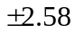 for 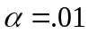). Study Tip: Think about explaining why you would use a z-test in this case.
  - Calculate the 99% confidence interval around your sample mean.
  - Calculate the 95% confidence interval around your sample mean.

- Under what conditions is assuming that a distribution of means will follow a normal curve reasonable?
- Indicate the mean and the standard deviation of the distribution of means for each of the following situations:

 | Population |  | Sample Size
 | Mean | Variance | N
 | 100 | 40 | 10
 | 100 | 10 | 10
 | 100 | 40 | 20

- SKIP Confidence Interval Question
In the graphs below, the purple bar represents population A. The orange bar represents population B. The mean of the 95% confidence interval is marked by the top of the bar graph.

Which of these graphs represent a p-value = 0.05 for testing a null hypothesis of no difference between populations?

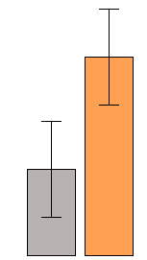 | 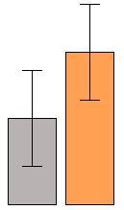 | 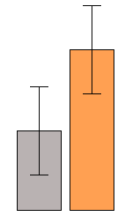

Homework #4: Hypothesis Testing with Sample Means and Confidence Intervals
Answers

Inferential Statistics and Intro to Hypothesis Testing

- Surprising Judge Problem
Answer this problem by calculating z-score in order to determine the probability of a certain score deviating from the sample mean.

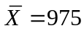
Standard Deviation=15
Judge’s Individual Score =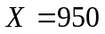

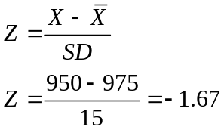

Next, you find this value on a Z table to find the probability of getting counts this low or lower. With a two-tailed α = .05, we see that the smaller portion of the curve 0.04746. We would expect counts as low as 950 people only 4.75% of the time.

Using a p-value of 0.05, this is a significant result. Our judge had a surprising answer if he is a conscientious counter.

- Define a p-value.
A p-value is the probability of an event occurring of some size or greater, given that the null hypothesis is true. Obviously, you do likely will not know whether the null hypothesis is true or false, but we can assume that it is for testing purposes. For example, if the weight of the population of all children in California was the same as the weight of the population of all children in Arizona, then samples obtained from those two populations should yield weights that are also the same. If you weigh two samples and obtain different weights, the p-value will represent the probability (likelihood) of finding a difference of that size or greater (think the tail of the distribution) between the two sample weights based on chance alone. More extreme differences are less likely to occur based on chance, so p-values will be greater for bigger difference whereas small differences will have larger p-values.

Note: When your data are sampled randomly from a population that is normally distributed, the p-value is an accurate probability of the event occurring under the null hypothesis. When a population is not normally distributed (e.g. an extremely skewed population), the p-value can be misleading. It is important to check that your data fit the assumptions of a statistical test before running analyses and drawing conclusions.

Hypothesis Testing and Confidence Intervals

- The standard deviation of the distribution of means is generally smaller than the standard deviation of the distribution of the population of individuals because there is less variation among means of samples of more than one score than there are among individual scores. This is because the likelihood of two extreme scores in the same direction randomly ending up in the same sample is less than the probability of each of those extreme scores being chosen individually.

Sample: Population:
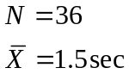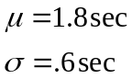

4a.
1. Population 1: Women (70-80 years old) who took part in special course program.
Population 2: General population of women (70-80 years old)

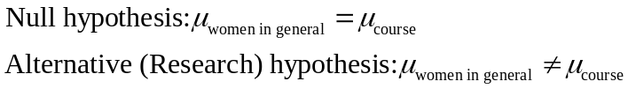
Note: Faster reaction times means there will be fewer seconds.

2. Comparison distribution: Z distribution (pop. mean and std. dev. are known) 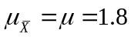
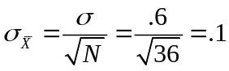

Z distribution is normal in shape; therefore empirical rule will hold

- Cutoff score for two-tailed test; 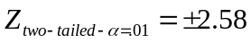; draw the rejection regions if this helps you

4. 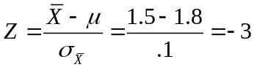

5. 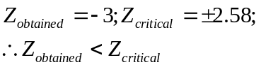

Conclusion: Reject Null hypothesis, -3 < -2.58; falls in the rejection region.
Thought question: What would you decide for a two-tailed test?
4b.
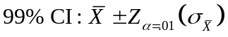 A confidence interval that is built around a sample mean is based on a sampling distribution of a given sample size. According to the central limit theorem, a sample of about 30 will produce a sampling distribution that is approximately normal in shape. A 99% Confidence Interval should be calculated using 2.58 from the Z distribution in order to obtain a range ±2.58 standard errors above and below the sample mean.

Note: Why use 2.58 rather than 2.57? Calculating the confidence interval by multiplying the standard error by 2.57 will provide slightly less than a 99% confidence interval (98.98% to be exact), whereas 2.58 standard errors will provide a confidence interval slightly larger than 99% (99.02%). If you want to make sure that you caption at least 99% of the scores around the mean, you should use 2.58 standard errors in the formula (2.57584 standard errors is more appropriate, but this is not in the z table so using 2.58 standard errors is a fair approximation). In other words, always make sure that your interval will capture at least as much as you claim it will.

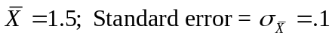

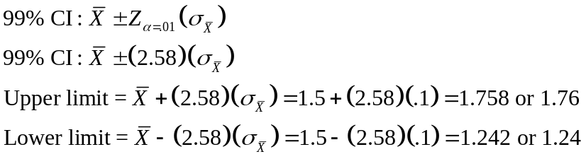
The probability is .99 that the interval calculated around the sample mean includes the true population mean (also .01 that the true mean is not included in the confidence interval).

4c.
95% Confidence Interval = 1.96 standard errors above and below the sample mean. The z-scores of ±1.96 provide the cutoffs for the region of the normal curve containing 95% of values.

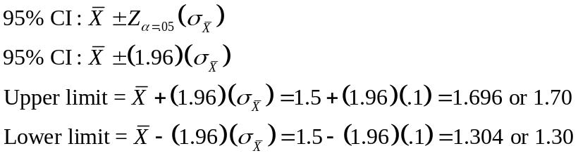
The probability is .95 that the interval calculated includes the true population mean (also .05 that the true mean is not included in the confidence interval).
- We can reasonably assume a normal distribution of means when either the population distribution is normal or when the sample size is greater than 30. Also consider the central-limit theorem.

- Note: In the question, you were provided the population’s variance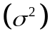, not its standard deviation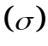. Therefore, we solve for 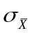using 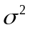.
Formula: 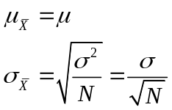

  - 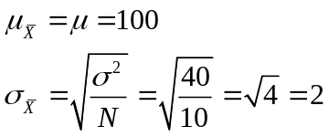

  - 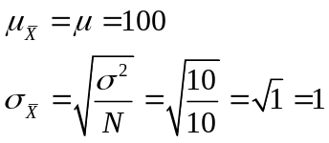

  - 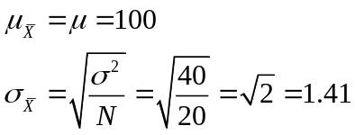

- Confidence interval problem

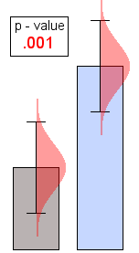 | 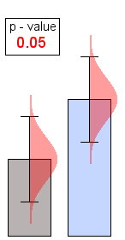 | 